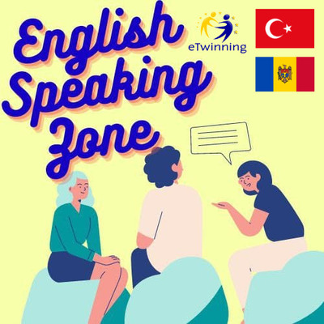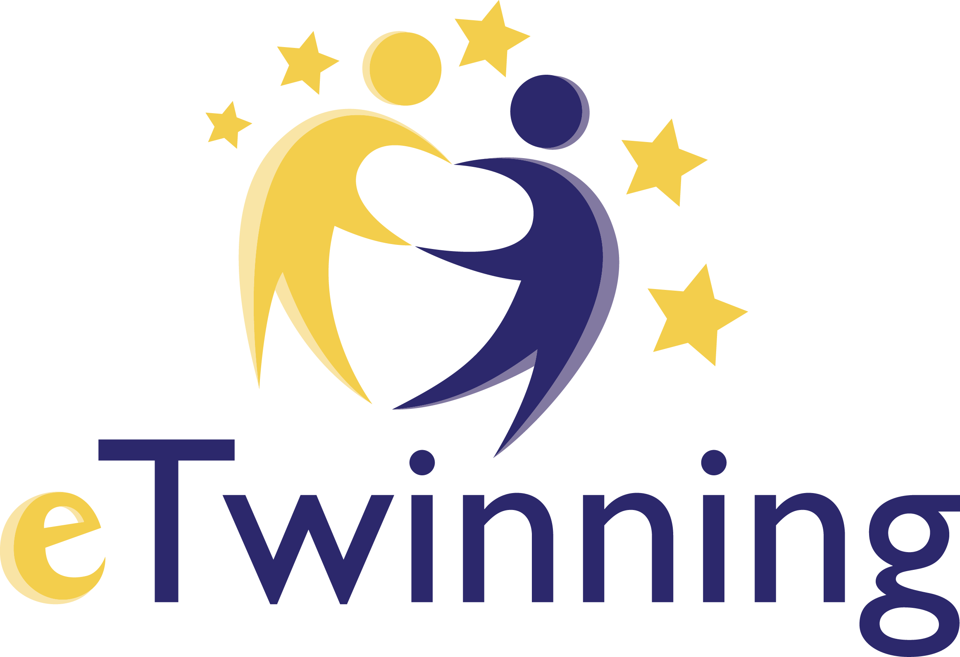

‘English Speaking Zone’ projesiyle;
Okulumuzda,İngilizce Konuşma alanı tasarladık.Tüm İngilizce Öğretmenleri ile gerçekleştirilmekte olan projede okulumuzun tüm öğrencileri diledikleri etkinliklerde aktif katılım sağlamaktadırlar.Öğrencilerimizin İngilizce pratik yapmaları için bir köşe belirledik.Öğrencilerimize uygulamalı dil ortamı sunduk ve öğrencilerimiz İngilizce dersi kazanımlarına uygun olarak dört temel dil becerisini sınıf ortamı dışında da kullanmaya başladılar,zaman zaman okulumuzun diğer alanlarınıda etkinliklere göre dizayn ederek faaliyetlerini gerçekleştirmektedirler. Bu projeyle,öğrenciler günlük hayattaki basit konuşmaları kolaylıkla anlayabilmekteler, aktiviteler sayesinde de özgüven kazanmaktadırlar. Aynı zamanda.takım çalışması yeterlilikleri ve yaşıtları ile konuşma becerileri de geliştimektedir.
Proje de emeği geçen tüm katılımcı öğretmen ve öğrencilerimize teşekkür ederiz.
With this Project;
We aim to design an English zone at school. We prepared a corner for the students to practice English. We exposed our students applied language environment. They began to use four basic language skills in accordance with English lesson outcomes. Student understandt simple conversation in daily life easily. With the help of the activities they gain self confidence and they promote their speaking abilities with their peers.
Aims of Our Project
expose students to the target language as much as possible
create a language learning environment
enable students to speak english in extracurricular time
use web 2 tools
build a bridge between different cultures
overcome personal difficulties like shyness in speaking
By the help of this project, we aim to:
- make our students speak fluently
- create daily language dialogues
- use new applications, teaching techniques and web 2.0 tools
- develop critical thinking and solving problems
- release potential of student
- improve communication skill and self-confidence
- promote a student-centered learning
- create an enjoyable learning environment at school
- become competent users of ICT tools in education positively
- enable students to develop different strategies.
- gain information about e safety issues
- develop collaboration between students-teachers-parents.
- improve the students’ foreign language skills.
- improve the students’ research skills.
Results of Our Project
We will expose our students to such environments so that they may develop their ability to express themselves. They will improve their English. They will develop their pronunciation.They will use language to communicate. The Project will raise students’ awareness of other cultural traditions .
By the end of the project,
- The students’ speaking skills, drama skills and creativity will develop.
- The students’ self-confident-autonomy will improve.
- The students will enjoy while learning.
- The climate of teaching will change with role-play and web 2.0 tools
- A final video, e-book and a virtual exhibition will be done for dissemination
- "English speaking zone" will be available for the voluntary students at school.
